Everything You Need to Know About Breeding in
Pokemon Uranium

Written by Youko
Guide version 0.8.15
This being updated continuously, but I've decided to post this before it's done so people have time to prepare while I type.
Edit: The guide is over half done. All that's left is the actual breeding itself, which I'm sure a lot of you have already caught onto how to do. Nonetheless, stay tuned!

Section 0: Intro

You may or may not know me, but my name is Youko. I run a modest pokemon hatchery over at this thread:

Youko's Hatchery
I specialize in high IV pokemon trading as well as free 4 and under IV pokemon giveaways! Feel free to drop by if you're looking for something complete or just want a freebie from my breeding rejects. (This is the end of the plug)

Disclaimer: I'm no expert in breeding. Actually, if anything, I've just barely gotten into it myself. However, seeing that I've been met with some mild success, I wanted to put this together for everyone who is interested but have no idea how to start. If you are familiar with breeding in the official pokemon games, I suggest you google for a more in depth guide on all the finer workings.

Before we start...

A WORD OF CAUTION

Breeding is time consuming. Do not walk into this expecting you'll be able to produce 5/6IV pokemon within 2-3 hours. Depending on your set up, luck, and what you're breeding for, it can literally take days. If you're not willing to put in that time, please speak to me or any of the other generous breeders in the trade and battle forum for headstart pokemon (4IVs) or just trade us for a complete pokemon (usually for other high IV or shinies).

As an example: I was only able to produce my first 5IV pokemon after 7 hours of breeding with a mostly female ratio pokemon. (Keep in mind I started from nothing). Stick to it! You'll get there eventually!

If you're determined to stick to this, then proceed away!

Section 1: Starting Out
-Breeding Terminology-
Make sure you are familiar with all these words before starting, because we'll be referencing them a lot! They also act as quick explanations of things covered in more detail later on.
Actual Stats - The actual number that's used to calculate damage done, taken, turn order, hp, etc. The first number of 3 in each attribute on a pokemon's stat page.
Ability - All pokemon have natural abilities that have some sort of function in (and sometimes out of) battle. You can find a pokemon's ability in its summary on the bottom of its stat page. Female pokemon will often pass down their ability.
Base stats: The innate stats a pokemon of that species has. All IVs and EVs add to the base stats in the final calculation of the pokemon's actual stats.
Base stat total: The result of adding all of a pokemon species' base stat values together. A good gauge of how strong pokemon are on a very basic level.
Breeding Chain - The act of breeding a pokemon of two egg groups with an already complete pokemon of one of its egg groups so one can pass IVs to a pokemon of the second egg group of the new pokemon (more on this below).
Effort Values/ EV - A stat that ranges from 0 to 252. Pokemon gain EV from defeating other pokemon or playing the punching bag minigame offered by the EV training ninjas. A pokemon can have a maximum of 510 EVs total (when you add all its EVs together). You can see a pokemon's EVs on its stat page as the 3rd stat number of each attribute. More information on Bulbapedia here.
Egg Group - Determines what Pokemon the pokemon is able to breed with. Pokemon of the same egg group will be able to breed, while pokemon of different egg groups will not be able to. The exception to this rule is the "Ditto" egg group.
Hidden Ability - An ability a pokemon may have. They are extremely rare and SHOULD be accessible via. Pokeradar chains. How effective it is, is up for debate. The only way to get pokemon with their hidden ability is to breed a female said ability with a male pokemon (60% chance) or breed a male pokemon with it with a ditto egg group (untested, but theoretically 20% chance).
Individual Values/ IV - A stat that ranges from 0 to 31 that each pokemon has in each of their stats. The IV dramatically impacts the calculation of a pokemon's actual stats. The higher IV, the higher the actual stat will be when you don't factor in level, nature, and EVs. The second value in a pokemon's stats for every attribute. IVs CANNOT BE CHANGED AFTER THE POKEMON HAS BEEN GENERATED! This what we mainly breed for. More information on Bulbapedia here.
Nature - The pokemon's personality. A pokemon's nature will either impact two of its stats or none of them (in this case, it is a neutral nature). Non-neutral natures will always increase one stat and decrease another by about 10%! You can find a pokemon's nature on the second page of their summary. More information on Bulbapedia here.
Original Trainer/ OT - The name of the trainer that originally generated the pokemon. Any eggs you hatch or pokemon you catch will have your trainer name as the OT.
----------------------------------------------------------------------------------
-Requirements-
-Absolute requirements-

Do not even consider breeding if you do not fulfill the following requirements:

- Access to Route 9 Pokemon Daycare (Complete the story until you get here)
- Destiny Knot (Mystery Gift. You can get this on the screen after you boot up the game. Just scroll down down from your save file)
- Pokemon Uranium Wiki Link (Click here)
- The pokemon you want to breed
- At least 20 000
- At least 3 Open storage boxes
- A lot of patience

-Important requirements-

Being able to fulfill these requirements will dramatically speed up breeding:
- A bicycle (Please look this up on the Pokemon Uranium wiki)
- A pokemon with the "Flame Body" ability (Raptorch evolutions, Hidden ability Pahar are both popular picks).
- Over 50 000 (pokeballs, everstones, everything else)
- Completed the "Ninja Reunion" sidequest (Located in Tsukinami Village, North from the Pokemart in the dojo. For more Information visit the Pokemon Uranium wiki)
- A female of the pokemon you want to breed
- Ability to take detailed notes and keep track of a large amount of data in a fast way (I recommend excel if you know how to use it)

-Loose Requirements-
Being able to fulfill these requirements will help with breeding speed and independence, but are not COMPLETELY necessary(but recommend).

- Access to Route 13 (Complete the story until you get here.)
- Access to Everstones (Bealbeach City Pokemart, 3rd floor, 200 each)
- False Swipe TM/Pokemon with False Swipe (BealBeach City Pokemart, 3rd floor, 20 000)

Section 2: How to Produce an Egg
-The Pokemon Daycare-
Before I explain the details of breeding, and how it all works, you need to learn how to actually breed first! On Route 9, just before the route 6 entrance, there's a path that heads north to the following building:

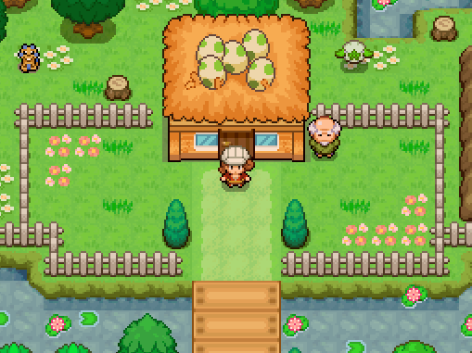

This is known as the Pokemon Daycare.
As a breeder, this place is your best friend.

When you go inside, you'll find a PC where you can access your storage boxes as well as an old woman and nurse. The nurse will heal your pokemon and speaking to the old lady will prompt her to ask you to deposit at most two pokemon for her to take care of.

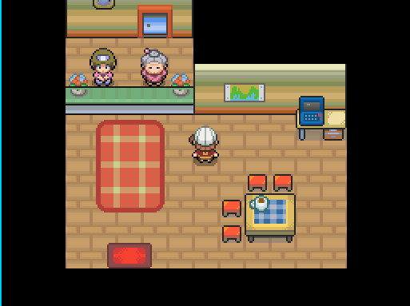

For every step you take, your submitted pokemon will gain exp and level. Keep in mind: If pokemon are supposed to learn a move, that move will overwrite the first move the pokemon has. If pokemon is supposed to evolve at a level, it will not until you level it once yourself. To take a pokemon out of the daycare, the old lady will charge you a base price of 100 and an addition 100 for each level the pokemon has gained.

Example:
You put in an Eevee and it gained 3 levels in the pokemon daycare.
It will cost 400 to withdraw it.

There is a very high chance you will be constantly changing pokemon to move items around and switch out individuals so be ready to front these costs even if they aren't all that high!

While the leveling functions of the daycare can be nice, what we're actually here for are the eggs! For every step you take, the pokemon you submitted into the daycare have a chance of producing an egg (assuming they can). Talking to the old man outside will give you a gauge of how quickly you'll be able to receive and egg.

He will start with something like this:

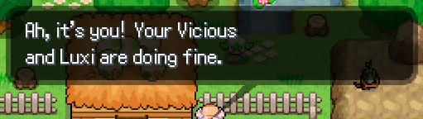

Followed by one of these:

"The two prefer to play with other Pokemon than each other"
(The pokemon will never produce an egg)

"The two don't seem to like each other"
(Low chance of an egg)

"The two seem to get along."
(Moderate chance of an egg)

"The two seem to get along very well"
(High chance of an egg)

The chance for an egg is increased if:
- Both pokemon are of the same species
- The pokemon have different OTs
However, this only applies if both are opposite genders and of the same egg group! For an in depth explanation on this, go to section 3 of this guide.

If an egg was generated while you were not on the map, when you re-enter it, he will appear to have "stepped up". Talking to him again will prompt him to offer you the egg.

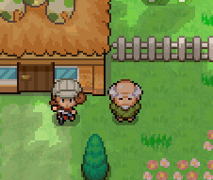
Old man stepping up.
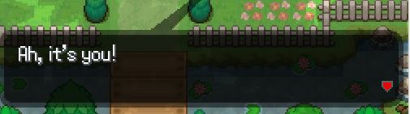
Message indicating an egg.

Note: The old man will only step up if the egg was generated while you were not on the map. If you have already claimed your egg, he will not return to his original position until you re-enter the map!
Because of this fact, if you are following this guide's method of hatching eggs, it's recommended that you speak to him periodically based on how likely you are to spawn an egg.

THE EGG WILL ALWAYS BE THE SPECIES OF THE FEMALE POKEMON!

This is pretty much why Female pokemon are more valuable than male ones.
The only exception to this is when breeding with the Ditto egg group. That will be exampled in the section below this one.
----------------------------------------------------------------------------------
-Hatching Eggs-
All you need to hatch your eggs is to move while having them in party. Different pokemon require differing amount of steps to hatch, but it usually requires at least 5000 steps to hatch a single egg.

By equipping a pokemon with the ability "Flame Body", however, the required amount is cut by half, but that's still at least 2500 steps!

Suggested Flame Body Pokemon:
Raptorch and All its evolutions: Raptorch is one of the starter pokemon you can pick at the start of your journey. Many are floating around on Wondertrade and given away as freebees from kind breeders so try asking around the forums.
Hidden Ability Pahar: Very tough to get in the wild. Like the Raptorch, a breeder may be willing to supply one to you.

How the heck are you going to get 2500 steps easily? Simple! Did you notice how straight and long route 9 was? Get on your bicycle and position yourself like so:

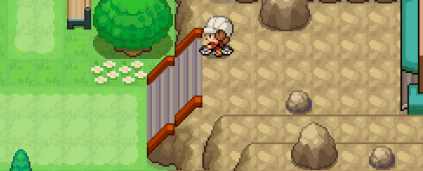
Hatching eggs: The easy way.
By keeping yourself on the tile just under the top of the stairs, you are able to keep going from one side of the map to the other (without accidentally exiting into route 6) by simply alternating the left and right. This is the best way to hatch eggs since you can absentmindedly keep alternating between the two buttons while you watch youtube videos or something with the game as the top window.
It is recommended that you empty your party and switch to your "Flame body" pokemon with five eggs so you are able to add steps to each and every egg you have with you. With the easily accessible PC in the actual daycare, it's very easy to drop off pokemon that you've already hatched so you have room to pick up another pokemon.

Section 3: Understanding the Mechanics of Breeding
-Egg Groups-

As explained in the terminology section, every pokemon has at least one egg group. The egg group of a pokemon determines what it is able to breed with. To find a pokemon's egg group, simply go to the Pokemon Uranium wiki and search the pokemon's name.

Example 1:
Eevees belong in the Field egg group.
Baashauns belong in the Field and Monster egg groups.
Because both Baashauns and Eevees belong to the Field egg group, they are able to breed successfully.

Example 2:
Eevees belong in the Field egg group.
Volchiks belong in the Dragon and Flying egg groups.
Because they do not share an egg group, they are unable to breed.

In total there are 14 egg groups that pokemon may belong to.

From Bulbapedia:

This is a list of Egg Groups by their index number in the games:
- Monster Group: Pokémon in this group are saurian/kaiju-like in appearance and nature.
- Water 1 Group: Pokémon in this group are amphibious in nature.
- Bug Group: Pokémon in this group are insectoid (bug-like) in appearance.
- Flying Group: Pokémon in this group are avian (bird-like) in appearance.
- Field Group: The largest group, Pokémon here are terrestrial in nature. In Stadium 2, this Egg Group was known as "Ground".
- Fairy Group: Pokémon in this group are petite and considered very cute.
- Grass Group: Pokémon in this group are plant-like in appearance. In Stadium 2, this Egg Group was known as "Plant".
- Human-Like Group: Pokémon in this group are fully bipedal. In Stadium 2, this Egg Group was known as "Humanshape".
- Water 3 Group: Pokémon in this group resemble aquatic invertebrates.
- Mineral Group: Pokémon in this group are inorganic in nature.
- Amorphous Group: Pokémon in this group are amorphous, having no definite form. In Stadium 2, this Egg Group was known as "Indeterminate".
- Water 2 Group: Pokémon in this group are piscine (fish-like) in appearance.
- Ditto Group: As the name implies, Ditto is the only Pokémon in this group, and is capable of breeding with all others (regardless of gender) aside from those in the Undiscovered and the Ditto group.
- Dragon Group: Pokémon in this group are draconic in appearance.
- Undiscovered Group: Pokémon in this group are unable to breed. In Stadium 2, this Egg Group was known as "No eggs".
To discover which egg group your pokemon is from, please take a visit to the Pokemon Uranium wiki. I cannot stress how great of a tool it is! This is the last time I will give you a link, so please keep it open!

Your lord and saviour:

Pokemon Uranium Wiki

- Ditto Duplicat, the Exception-

Unlike the official games, Pokemon Uranium features a pokemon called "Duplicat" that, for all intensive purposes, functions as this game's ditto. The ditto egg group is special in the sense that it is able to breed with any pokemon outside of the undiscovered group and produce an egg, no matter the gender of the original pokemon. As such, Duplicats are an easy way to transfer IVs without producing a breeding chain (more on this later) and a useful tool in every breeder's belt.

The resulting pokemon will always be the same species as non-Duplicat, no matter the gender of said pokemon!

Duplicat, the smuggest 4-eyed cat ever.
-How to Find a Duplicat/ How many you are required to catch-
Welcome to your first official hurdle! While I'll get into the specifics of what you're supposed to do with a duplicat once we get into the nitty gritty of IV breeding, let me tell to where you actually catch one!
As far as my experience goes with the little suckers, they are almost always exclusive to route 13 (just outside of Venesi town). The spawn rate is an extremely low 5% and you're expected to literally catch something like 60 of these guys (no seriously). The goal is to try to get one duplicat for each stat that has a perfect IV in it.
In other words:
You need a Duplicat with a Perfect HP IV, another with perfect Atk IV... etc.
The rate of catching one of these is somewhere around encountering a female eevee in the wild... and that's not even saying anything about it being a perfect IV in the stat you want!
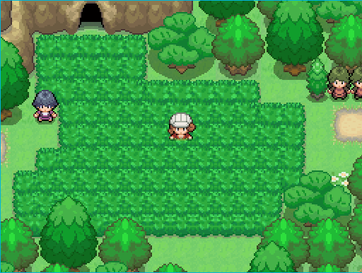
You are going to hate this patch of grass in a few hours.
How painful this step is completely determined by your personal standards for what a "good enough" IV is and how good your starting pokemon's IVs are.

Think of it like this: For each IV you're okay with keeping from your starting pokemon, that's one less duplicat to catch.

- How To Actually Catch the Damn Thing!-
Remember how I asked you to get a "False Swipe" TM? Well, it's time to put that to some good use! Chances are, at this point in the game you are so over powered that you'll destroy the poor little guys in literally on hit with even your weakest move from pokemon on your team. Getting a random pokemon of its level to fight with it is a pain and slow as hell, so how do we try to remedy this problem?
Take a look at False Swipes' move description:
False Swipe inflicts damage, but will leave the target with 1 HP if it would otherwise cause it to faint. If the target has 1 HP remaining, False Swipe will hit and leave the target at 1 HP.

In other words: This is the perfect move to almost 1-hit-KO the duplicat ripe for the catching!
That said, duplicats have really annoying skills like confuse ray (confuse your pokemon) and substitute (Take no damage for one attack at the cost of some HP) that can prevent you from lowering their HP. Because of this, it's recommended that you get a pokemon with an extremely high speed stat so you almost always go first (except for when the duplicat has the Prankster skill) so you can throw down your move before it can act.
Don't worry, if the Duplicat doesn't have enough HP for a substitute, the move will simply fail.
"But, Youko, I don't want to teach a pokemon False Swipe!"
...I'm not sure why you won't save yourself the trouble, but if you're that against false swipe, you can throw quick balls. Why? Take a look at the description for them:
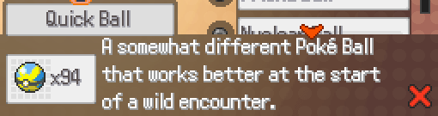
Basically, the Quick Ball has a x4(x5?) catch rate compared to a normal pokeball at the start of a battle. There's a fairly good chance you'll be able to.
You can find them on the 2nd floor of the Bealbeach PokeMart for 1000 each.
Considering how many duplicats you will have to hunt, I'm not sure why you would go for this option, but here you are....
----------------------------------------------------------------------------------

-Inheriting IVs-
Here comes the main crux of what you need to understand to be a successful breeder. Honestly, I'm considering just bolding this whole damn section, but that would defeat the point. You better focus, because I'm about to explain all this crazy stuff to you!
-How the Game Handles IVs from Eggs-

When a pokemon is generated from the wild or hatched from an egg, the game rolls IVs for each of its stats for a value between 0 and 31. Usually you end up with completely random IVs like this:

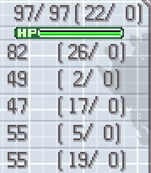
However, with breeding, the game then takes into account the IV of the parent pokemon and selects three random values between both pokemon and overwrite the original IV of the baby with them.
It is entirely possible that only the IVs from one parent is inherited.
All IVs are listed in this order in the following examples:
Hp Atk Def Sp.Atk Sp.Def Spd
Example 1:
Before Adjusting for Breeding:
Parent 1: 12 18 30 04 31 00
Parent 2: 00 08 28 07 03 19
Child : 15 31 05 27 23 01
After Adjusting for Breeding:
The bold numbers were inherited.
Parent 1: 12 18 30 04 31 00
Parent 2: 00 08 28 07 03 19
Baby : 12 31 28 27 23 19
Example 2:
Before Adjusting for Breeding:
Parent 1: 21 09 31 06 14 10
Parent 2: 10 28 13 17 24 29
Child : 28 11 15 00 17 03
After Adjusting for Breeding:
The bold numbers were inherited.
Parent 1: 21 09 31 06 14 10
Parent 2: 10 28 13 17 24 29
Baby : 28 11 31 06 14 03
Right now you may be asking yourself:
If a pokemon only inherits 3 IVs, how can you reliably produce 5 IV pokemon?
Allow me to introduce you to the magical item that is called the DESTINY KNOT(from Mystery Gift. For details look at my requirements for breeding in section 1)!

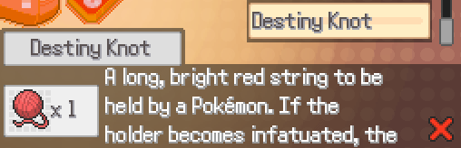

Now, the description may be cut off, but to sum up what this item does:

IF ONE OF THE TWO POKEMON IN THE DAYCARE ARE HOLDING THE DESTINY KNOT, 5 IVS WILL BE PASSED INSTEAD OF 3!

I cannot stress enough HOW IMPORTANT this item is. Without it, even if you literally breed 6IV pokemon together, you will almost always get 3IV pokemon!
Do NOT. I REPEAT. DO NOT LOSE THIS ITEM.

Okay, now that we can ensure that we can pass 5IVs, how do we make sure we pass the five we WANT?
Allow me to introduce you to your next six most important items: The Power Bands! (Received as rewards for the Ninja Reunion sidequest. Go up to my breeding requirements for a link to the wiki article.)
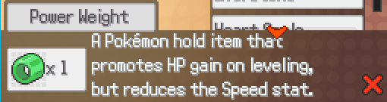
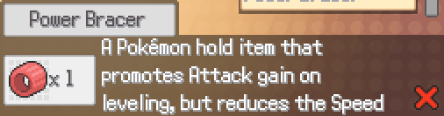
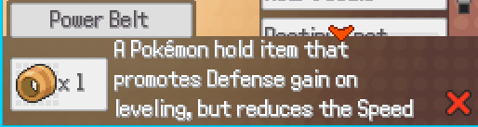
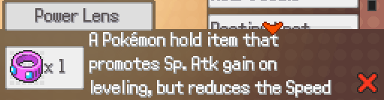
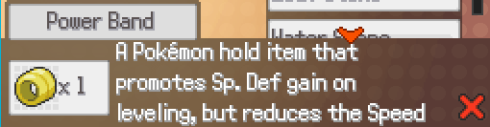
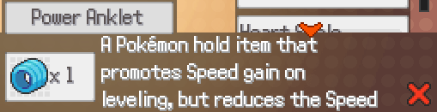
At this point I suspect you'll be looking at me and going:
"But Youko, aren't we breeding for IVs? What the heck does EV training items have to do with it this?"

Well let me tell you:

If a pokemon is holding one of the power bands, its IV of the corresponding stat that the band helps train will be guaranteed to transfer the baby!
Since the effects of the Destiny Knot and Power Bands stack, you can use them together to push for your target IVs!
Keep in mind that this does not mean that the baby will get 6IV, just that one of the 5IVs (or 3 if you're not using the destiny knot for SOME reason) will be the IV of the parent holding the power band item.
Example 1:
No items:
Parent 1 (no items): 31 31 31 31 31 31
Parent 2 (no items): 00 18 24 17 09 27
Child : 31 14 28 17 01 27
With the use of Destiny Knot and a Power Band together:
Parent 1 (Power Bracer): 31 31 31 31 31 31
Parent 2 (Destiny Knot) : 00 18 24 17 09 27
Child: : 31 31 28 17 31 27
I hope all this makes sense to you, because if it doesn't you should read over it until or do give up right now!
----------------------------------------------------------------------------------

-Inheriting Everything Else-
Since everything else is very simple, I'll just list them off one by one.

Gender: Completely random. Please refer to your gender ratio for the pokemon on the wiki to get an idea of what to expect.

Ability: The pokemon will inherit the Female pokemon's ability 60% of time automatically. Otherwise, it is randomly picked between any of the pokemon's normal abilities. When breeding with a duplicat, all pokemon (including male and genderless) have a 20% chance of passing their ability.

THIS MEANS YOU CANNOT GET A HIDDEN ABILITY POKEMON FROM NORMAL ABILITY PARENTS!

Nature: The pokemon will inherit the nature of the parent holding the everstone. If neither is holding one, then the nature is completely random.

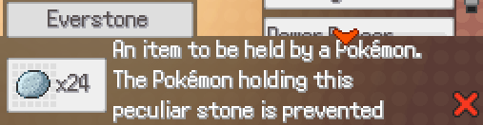
(Bealbeach City Pokemart, 3rd floor, 200 each)

Egg Moves: I do not deal with egg moves. I'm sorry, but I just don't have the patience for it! Please look it up yourself. (sorry)
Pokeball: I- what? For those of you who care:
Here's the bulbapedia description for it...
Starting in Generation VI, the Poké Ball of the female Pokémon (other than a Master Ball and Cherish Ball, which result in the default standard Poké Ball) will be passed down to its offspring. Male and genderless Pokémon (including Ditto) have no impact on the type of Poké Ball inherited; as such, when breeding a male or genderless Pokémon with Ditto (which is the only way to breed certain species), the offspring is always obtained in a standard Poké Ball.

Section 4: Planning Your Pokemon
-Picking a Pokemon-
While I assume a lot of you are looking into getting perfect IV pokemon, the truth of the matter is that without headstart pokemon (read: pokemon with at least 3IVs), it will be very hard to actually get to the point where you reach that goal. Because of this, I urge you to take a look at the final evolution of the pokemon up on the wiki and see its base stat distribution before deciding to actually breed something.
-Base Stat Totals-
Now, if you're on the wiki (which you should be), you'll notice that every pokemon has a base stat total. The base stat total is exactly what it sounds like: the total of all the base stats of the pokemon added together. The base stat total is a good way to gauge a pokemon's overall strength. The base stat totals between a pokemon's evolutions are different. This is the reason why you feel like you get a massive strength boost when you evolve a pokemon!.
In general, a higher base stat total will usually result in a stronger pokemon overall.

Due to this principle, even if you really like a pokemon, please realise that there is a very good chance it will not be worth IV breeding for due to its base stat total.

If you don't care about raw potential (which a lot of people clearly don't based off the love for eevees despite their sub-500 base stat total) and just want to make your weaker pokemon viable, IV training can actually said weaker pokemon to the level of non-IV trained strong pokemon. If you are willing to invest the hours for it (or just beg one of us breeders who decided to invest the hours into it), I won't stop you.

-Picking a Suitable Role in Battle-
Different pokemon have different base stats, and thus, are far easier to fight into different roles.
Yes, I know, you want cool looking pokemon, but the thing is a lot of the time, some really cool-looking pokemon have really mediocre or ill-fitting stats for current purposes!
A prime example of this would be the final evolution of Orchynx, Metalynx. Yes, it's a super cool metal cat, but you take a look at is base stats, you'll see that it's actually designed to be a tank with high def and sp. def. Because of this, it has an extremely mediocre speed!
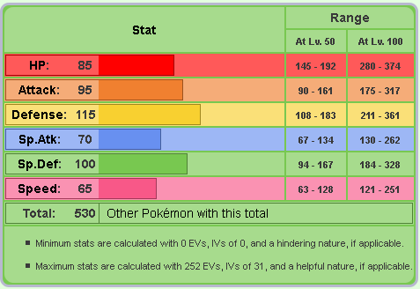
Metalynx's base stats Via. Pokemon Uranium Wiki

This is only further emphaized more when you consider pokemon like Inflagetah who are known for their speed:
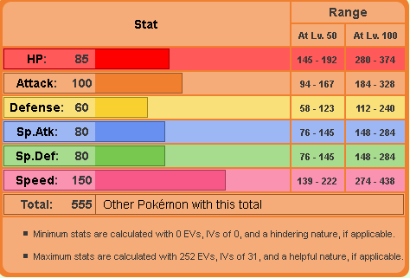
Inflagetah's base stats Via. Pokemon Uranium Wiki
What does all this mean? It means that even if you had a Metalynx with a perfect IV in speed, had a nature that boosted speed and trained for 252 EV(maximum amount) in speed:
METALYNX WOULD STILL BE SLOWER THAN A INFLAGETAH OF THE SAME LEVEL AT ITS WORST POSSIBLE SPEED!
Does this mean a perfectly built speed Metalynx is worthless? No, it does not. It does however mean, that you will almost always been out-sped by anyone who decided to actually pick a proper pokemon for the role, so please think carefully about everything to do with a specific species of pokemon before committing to breeding!
If you're not careful, you may be investing things like nature and EVs in a dump stat for that pokemon!
This same principle applies to move set! If you give a pokemon with high sp.atk all physical moves, the moves will do damage off the atk stat instead of the sp. atk stat!
Symbol for Physical moves:
Symbol for Sp. Atk moves:

----------------------------------------------------------------------------------
-Picking a Suitable Nature-
Now that you actually have some idea about where to go with your planned pokemon, it's time to actually decide a nature. This step is completely optional if you don't want the added difficulty. As I mentioned in the terminology section, a pokemon's nature will give you an addition 10% in one stat and decrease 10% from another stat. Which stats are increased/decreased are completely determined by the actual nature itself.
Since you know what stats you want to now focus on, it's time to take a look at the chart to decide which nature you're going to try to aim for.
Remember: A nature is normally determined randomly upon generation, but can be inherited if one of the parents holds an everstone.
To save you some time, I've copied the chart from Bulbapedia for you to look at:
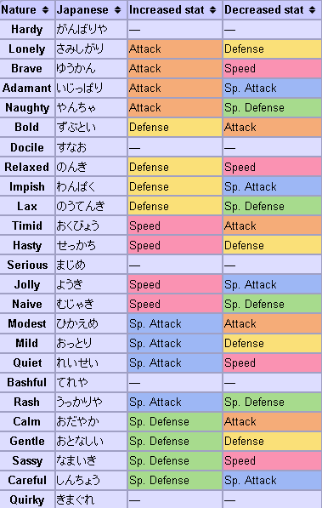

Section 5: The Nitty Gritty of Breeding
You better be paying attention, because things are about to get real technical here!

-Starting from Scratch-
Assuming you've actually followed all my instructions so far, you are finally ready to start breeding your pokemon!
If you've been following my instructions, you should have the following ready:
- A duplicat with a perfect IV for each stat you want perfect
- A pokemon that is from the same evolution line as your target pokemon
- An empty party with only a pokemon that has the "Flame body" skill in it.
- A bike
- Destiny Knot and Power Bands
- Everstones
- A lot of free time
- Something to take notes on
- Organized boxes to place things
- A clear idea of what your end goal is
To make this as simple as possible, I will be giving you step-by-step instructions about how to breed for a perfect IV pokemon (with and without the target nature) starting from HP and going all the way down its stats to speed. You do not have to pass IVs down in this order. I am simply demonstrating it for simplicity.
Let's get started!
Step 1: Passing IVs from Duplicats to your TP.
The first thing you need to do is to actually pass a stat from the duplicat to your target pokemon (TP for now on).
Start by take your TP and HP Duplicat out of their boxes.
If you're focusing on Nature and the TP matches your target nature, give it an everstone to hold.
If you're not focusing on nature, or want to put it off until later (recommended), don't give your TP anything to hold.
Give your duplicat the Power Weight to hold.
Insert both pokemon into the daycare and ride around until you get an egg.
Once you have an egg, proceed to hatch it (while possibly picking up more eggs along the way).
You should eventually end up with a pokemon like with the following IVs we'll call PKM A:
(xx = random value)
PKM A: 31 xx xx xx xx xx
Once you get this, pull both duplicat and your TP out of the daycare and take off their items. After you've deposited them safely into your boxes, take out your Atk Duplicat.
If focusing on nature:
Give the pokemon with the nature you want the Everstone and give the other pokemon the Destiny Knot.
If focusing on IV/No pokemon are the nature you want:
Give PKM A the Destiny Knot.
Give Duplicat the Power Bracer.
Why use the destiny knot when there is only 1 IV to pass down?
Since power bands do not stack their effects, having the destiny knot equipped gives a better chance of passing on the HP IV. Since we want to get to 2 IV pokemon as soon as possible, we do this to speed things up.
Keep hatching eggs until you end up with IVs like this:
PKM B: 31 31 xx xx xx xx
Once you reach this point, repeat the steps you did for PKM B, only swapping out PKM A with PKM B and the duplicat for your def duplicat.
Their items should be as such:
If focusing on nature:
Nature holder: Everstone
Other pokemon: Destiny Knot
If focusing on IV/No pokemon are the nature you want:
PKM B: Destiny Knot.
Duplicat: the Power Bracer.
Now put those two in the damn daycare and keep riding until you get a pokemon (PKM C) with IVs like this:
PKM C: 31 31 31 xx xx xx
(Can be female or male)

At this point, if you are breeding Genderless pokemon, keep following this method until you reach your Target Pokemon! Good Luck!
If you are not breeding genderless pokemon, please keep reading.
Step 2: ...Now do it all over again
Right now you're probably saying:
All over again? What the heck is that supposed to mean!? I worked my butt off for 3IVs!
This is where the handy tool I linked to earlier comes into play. You see, the chance to get a 4IV pokemon with a 3IV and 1IV parent are extremely small compared and only gets smaller as you progress up to 6IVs. As such, instead we will breed 3IV parents together so we have a very high chance of producing a 4IV pokemon.
...This however means that you will have to make a whole other 3IV pokemon, only with the opposite IVs that your first one had. (Eg, if PKM C has perfect Hp, Atk, Def, PKM D has to have perfect Sp.Atk, Sp.Def, Spd) while being the opposite gender. (If PKM C is female, PKM needs to be male).
It's a tough bill to fill, but completely necessary if you want to lower the amount of eggs total you need to hatch.

-Breeding Chains-
Feel free to ignore this section if you are determined to only ever breed one species of pokemon.
If you, however, are looking to breed your whole team or start a breeding thread, reading this section will make your life infinitely easier.
Right now you're probably going:
"Wait, what? Aren't egg groups set, Youko? Why would I need to pick something like that?"
Basically, as I've established before, pokemon of the same egg group can breed together, so you want to establish a "chain" of pokemon where you can potentially pass high IVs from one species to another without having to resort back to duplicats.
Example:
You want to breed Volchik(Flying, Dragon) and Eevee(Field).
Volchik and Eevee cannot breed because they do not belong to a common egg group.
Notice, however, Dunsparce(Dragon, Field) belongs to one of each of their groups, therefore, Dunsparce can breed with both Volchik AND Eevee.
Since it is much easier to get great IVs from 5IV/6IV pokemon by breeding with 6/5IV pokemon (literally shortens the time by 300% at least) than to start all over again with duplicats, it would make more sense to breed a perfect Eevee or Volchik until you produce a perfect Dunsparce to breed with the other.
This is called a Breeding Chain
.

It is always the hardest to get to perfect IVs from pokemon with only a few perfect IVs because of the way chance works. It is however, very easy to get high IV pokemon if you breed together 5IV ones or even have one pokemon with near perfect IVs.

How do we use that to our advantage?

We create a breeding chain:

A breeding chain is basically where you breed one (near)perfect male pokemon with a female pokemon of the same egg group and the egg group of the pokemon you're targeting next to produce 2-4IV pokemon. After you've produced a (near)perfect male pokemon of the second species, since it can breed with your target pokemon, you then pair it up with a female of your target and breed it until you reach your goal.

Since that may be somewhat confusing, let's use an example to explain this:

